Lab sheet 06 CIS31041-Practical for Data Mining
Reg No: SEU-IS-19-ICT-003

Topic: Association Rule Mining
Aim: Getting practices with Data Preprocessing
Getting practices with Association Rule Mining
Task: Data Preprocessing
Data cleaning Data Discretization Question 01:
The description of Bank.csv is given here,
Attribute | Description
id | a unique identification number
age | age of customer in years (numeric)
sex | MALE / FEMALE
region | inner_city/rural/suburban/town
income | income of customer (numeric)
married | is the customer married (YES/NO)
children | number of children (numeric)
car | does the customer own a car (YES/NO)
save_acct | does the customer have a saving account (YES/NO)
current_acct | does the customer have a current account (YES/NO)
mortgage | does the customer have a mortgage (YES/NO)
pep | did the customer buy a PEP (Personal Equity Plan) after the last mailing (YES/NO)

- Import the data set into Weka
- Visualize All the attribute and interpret the result
- Visualize the scatter plot of the attribute and explain the attribute relations
- Convert the Bank.csv file format to Bank.arff and reopen the Bank.arff file.
- Preprocess the source file
- Convert the numerical value to nominal data type.
- Change the data label of the converted nominal data type.
- Reopen the edited resource file
- Apply the association rule mining ‘Apriori’
- Explain the out put that gain from association rule mining
- Find the relation with PEP attribute When PEP is no and PEP is yes
- Set the class attribute as marital status

Question 02
The Given Iris Plants Database.csv file contains the attribute of Iris Plants. There’re five attributes about the plant which are, sepal length in cm, sepal width in cm, petal length in cm, petal width in cm, and class.
- Import the data set into Weka
- Visualize All the attribute and interpret the result
- Visualize the scatter plot of the attribute and explain the attribute relations
iv. Preprocess the source file
- discretize all the attribute.
vi. Change the data label of the converted nominal data type.
- Apply the association rule mining ‘Apriori’ and set the class attribute as class
- Explain the association rule mining

Question 01:
- Import the data set into Weka
- Open the weka software Click on Explorer then weka Explorer will open within that click on open file Go to the location of the dataset file Double click on that and open it.

- Visualize All the attribute and interpret the result
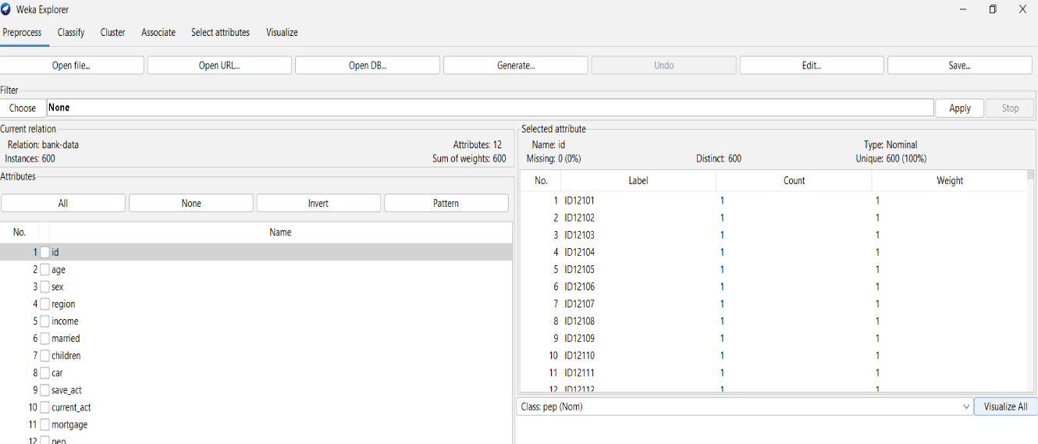

- Click on the Visualized button
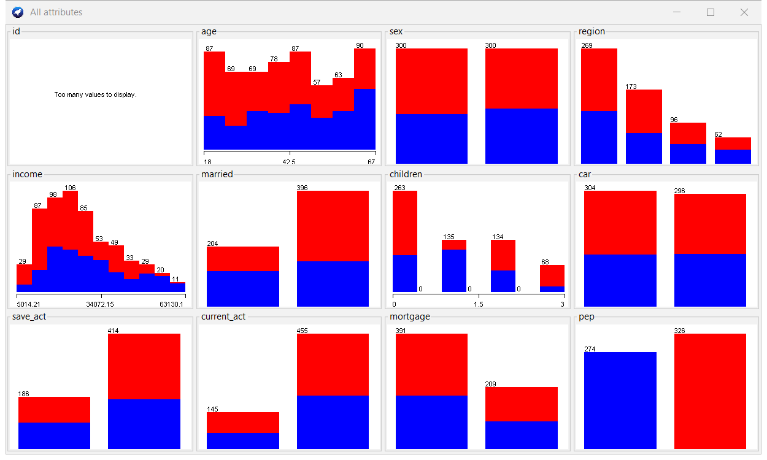

- Visualize the scatter plot of the attribute and explain the attribute relations
- In the top menu bar click on the visualized tab
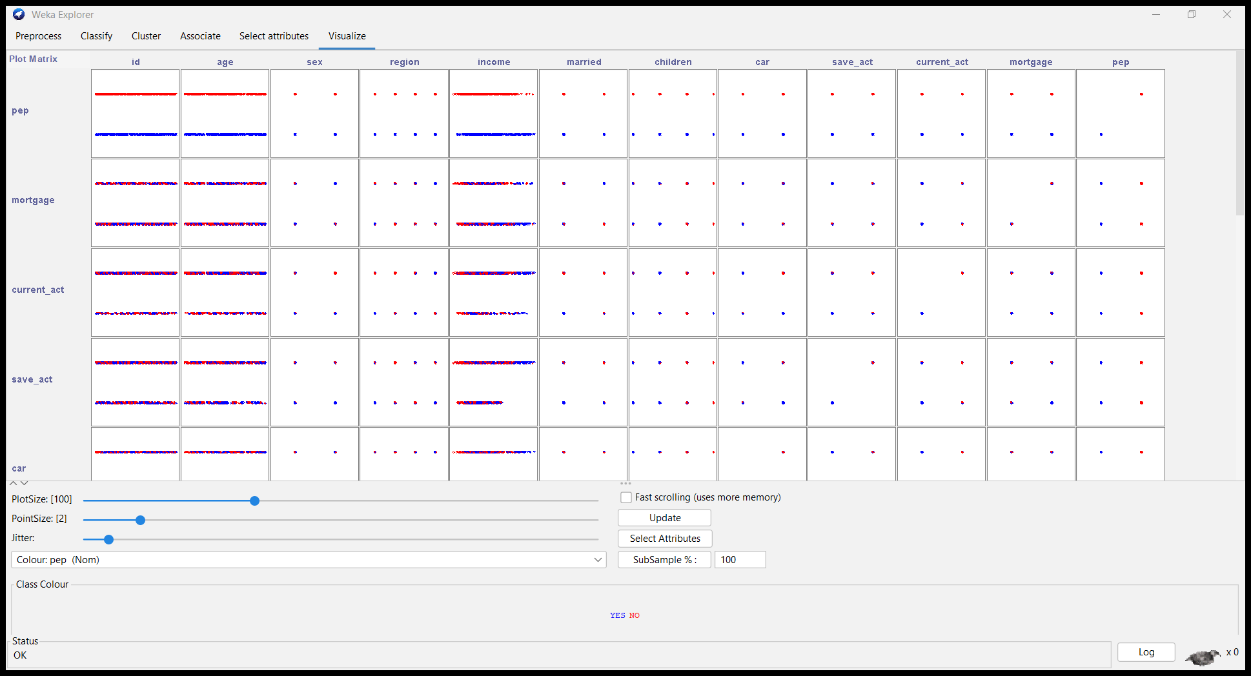

- Age vs. Income:
There seems to be a positive correlation between age and income. As age increases, income tends to rise as well.
- Region vs. Income:
The scatter plot shows that income varies across different regions. Metropolitan areas tend to have higher incomes, while suburban and town/rural areas show lower income levels.

- Marital Status (Married) vs. Children:
Married individuals tend to have more children. The plot shows a positive relationship between marital status and the number of children.
- Car Ownership vs. Income:
Car ownership appears to be associated with higher income. The data points cluster more toward the right side of the plot for car owners.
- Savings Account (save_act) vs. Current Account (current_act):
There’s no clear linear relationship between having a savings account and having a current account. Some individuals have both, while others have only one or none.

- Mortgage vs. Personal Equity Plan (pep):
The scatter plot suggests that individuals with a mortgage are less likely to have a personal equity plan (pep)There’s a negative correlation between these two attributes.

- Convert the Bank.csv file format to Bank.arff and reopen the Bank.arff file.
- Click on save button go to the file location which you want to save the file change the file type as .arff Click on save

- Preprocess the source file
In the preprocess there are to ways which is remove the unwanted attributes second one is check if there is any missing value there
- Above given data sid is not unwanted attribute so we have to remove that attributre there is two methods to remove the attribute which is filter method and directly select and remove here, I used second method first I select the id attribute After there is a option called Remove click on it

- Convert the numerical value to nominal data type.
First select the attribute which you want to convert in to nominal Click on “Choose” button under the option called filter Then filter pane will appear Click on filter folder click on unsupervised folder click on attribute folder finally click on discretizes option and click on ok In the filter option Infront of the choose option it will shows the selected filter option click on it Then Genaric object editor pane will appear Enter the relevant attribute number and the number of bin and click on ok click on apply

- Change the data label of the converted nominal data type.
- After converting numerical value to nominal data type save the worksheet Open it from Notepad ++ select the category of the data which you want to change the label Press Ctrl+f then Click on replace tab in the “replace with” text field enter the new label nameClick on replace all finally save the file

- Reopen the edited resource file
- Again go to the weka software Click on Explorer then weka Explorer will open within that click on open file Go to the location of the dataset file Double click on that and open it.

- Apply the association rule mining ‘Apriori’
- Click on Associate tab Next under the associator option check whether is Aprior is choose Open the Aprior biaog box According to the needs give the values for relevant field Click on ok Click on start

- Explain the out put that gain from association rule mining
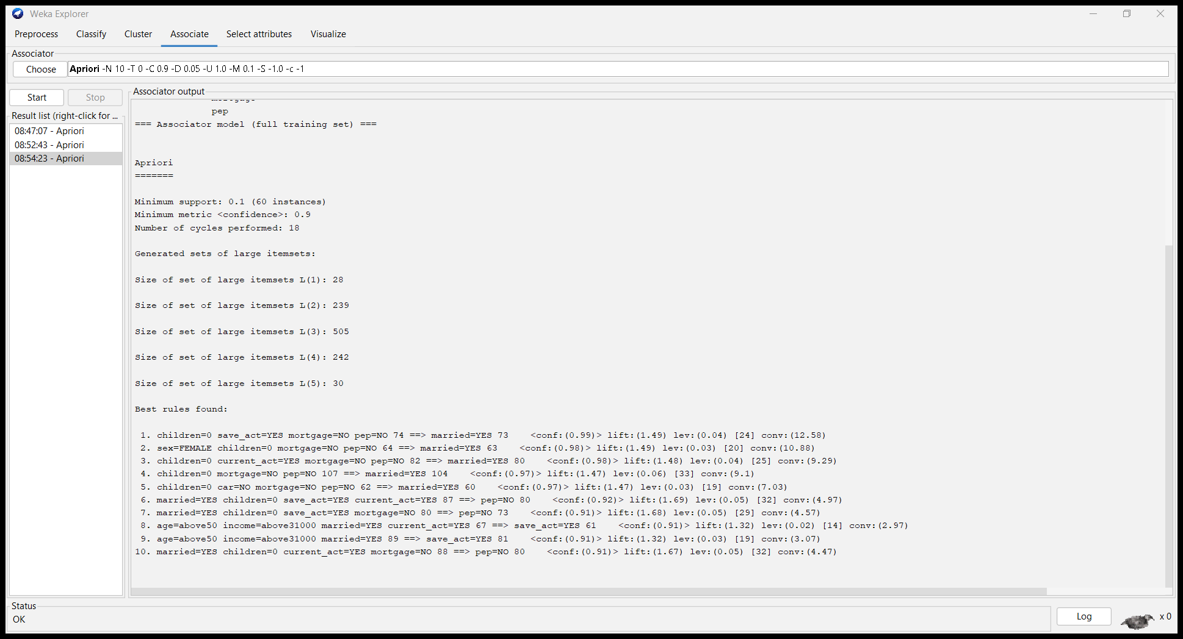

Given data set have 11 attributes and 600 instances after applying association rule mining we got the out put like below

Apriori Parameters:
- Minimum support 0.1(60instances) ,
- minimum metric <confidence> 0.9
- Number of cycles performed 18

Generated sets of large itemset:
- L(1): 28 itemset
- L(2): 239 itemset
- L(3): 505 itemset
- L(4): 242 itemset
- L(5): 30 itemset

Applying Associate rule mining its generated best 10 rules

- 1st rule 74 peoples don’t have children, but they have saving account, and also, they don’t have mortgage and pep account. Among those 73 married
- 2nd rule 64 peoples are female they don’t have children, and they don’t have mortgage and pep account. Among those 63 married
- 3rd rule 82 peoples don’t have children, but they have current account, and also, they don’t have mortgage and pep account. Among those 80 married
- 4th the peoples don’t have children, and they don’t have mortgage and pep among those 104 are married
- 5th rule 62 peoples don’t have children and they don’t have car ,mortgage and pep account. Among those 60 married
- 6th rule there are 87 peoples are married but no children they have a saving account and current account but among those 80 peoples don’t have PEP.
- 7th rule there are 80 peoples are married but no children they have a saving account and no mortgage but among those 73 customers don’t have PEP.
- 8th rule 67 peoples ages are above 50 they gain more than 31000 income and already they married. They have current account. Among those 61 peoples have saving account
- 9th rule 89 peoples ages are above 50 they gain more than 31000 incomes already they married. Among those 81 peoples have saving account
- 10th rule there are 88 peoples are married but no children they have a current account and mortgage but among those 80 peoples don’t have PEP

- Find the relation with PEP attribute When PEP is no and PEP is yes
Go the Apriori setting panel within that change the car as True and class index as -1, finally change the minMetric as 0.8 After changes click on ok Click on start
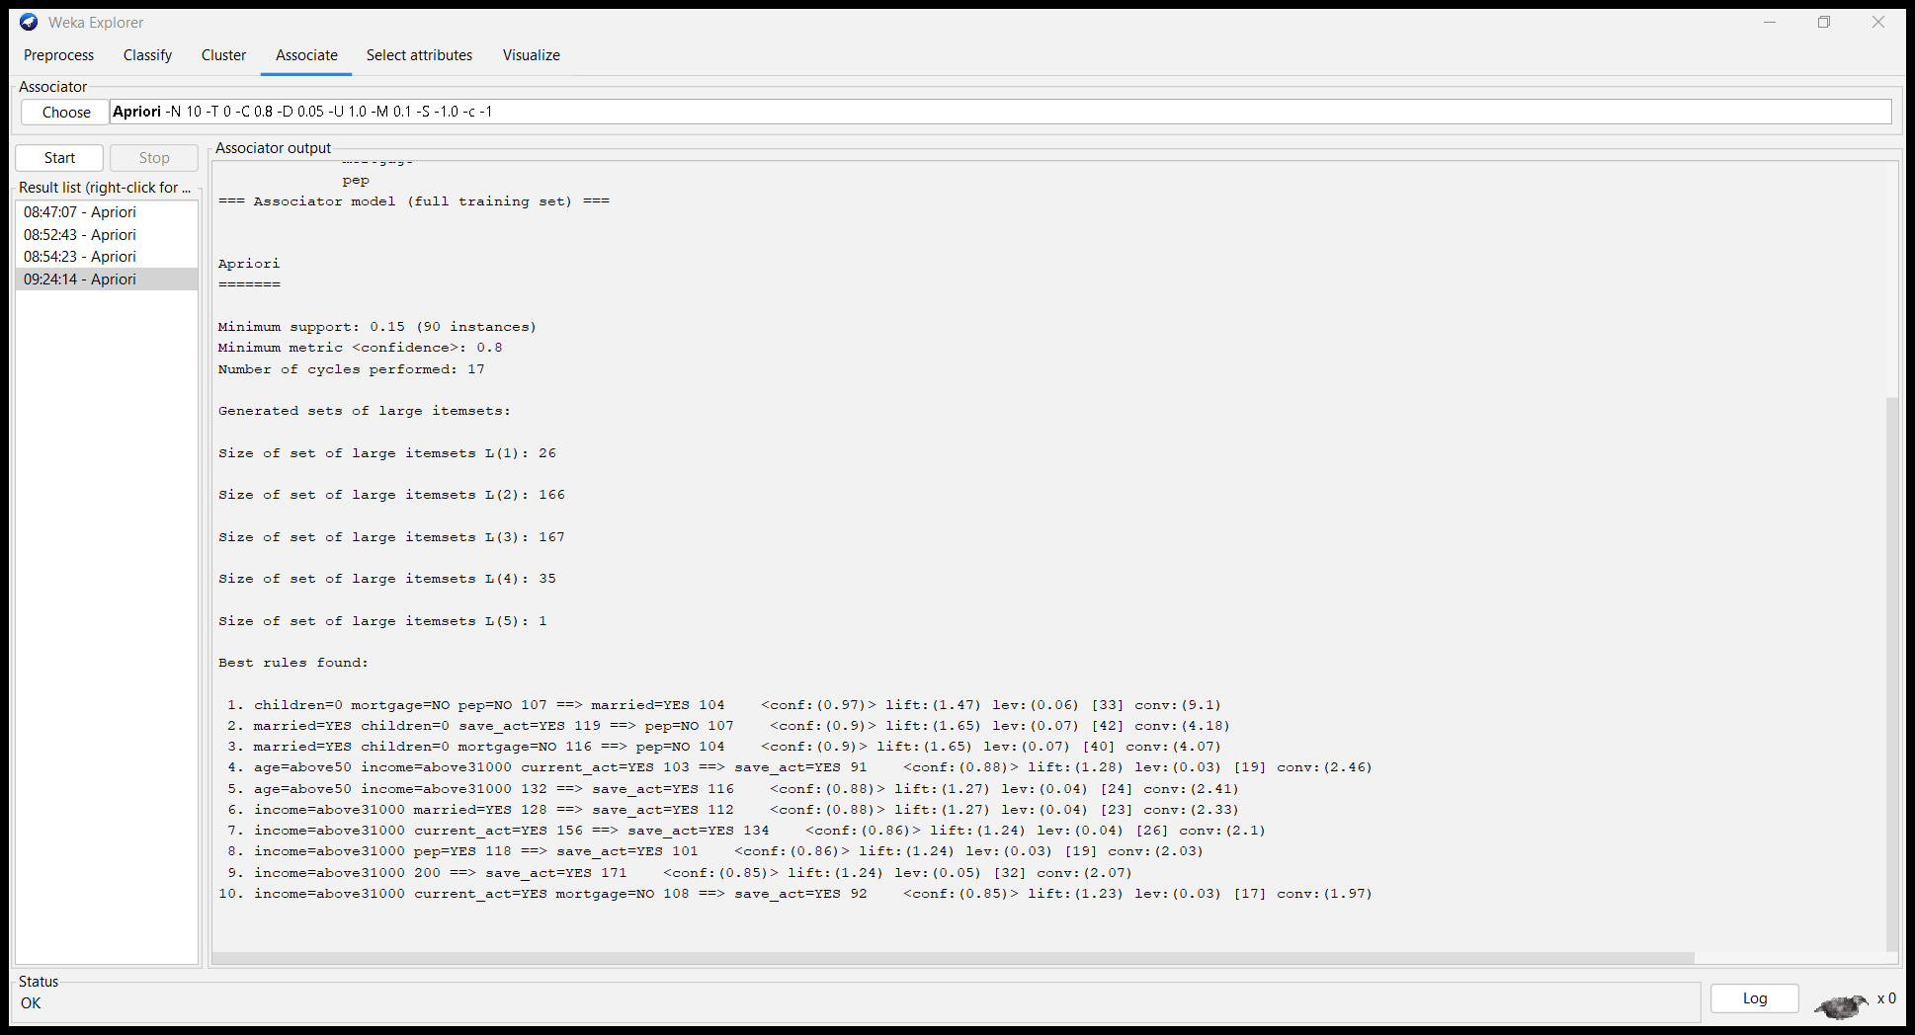

- In the first rule there are 87 peoples are married but no children they have a saving account and current account but among those 80 customers don’t have PEP
- In the 2nd rule there are 80 peoples are married but no children they have a saving account and no mortgage but among those 73 customers don’t have PEP
- In the 3rd rule there are 88 peoples are married but no children they have a current account and no mortgage but among those 80 customers don’t have PEP
- In the 4th rule there are 70 married females but no children and no mortgage but among those 80 females don’t have PEP
- In the 5th rule there are 119 peoples are married but no children they have a saving account but among those 107 customers don’t have PEP
- In the 6th rule there are 116 peoples are married but no children and no mortgage among those 114 peoples don’t have PEP
- In the 7th rule there are 67 peoples are married but no children, don’t have car and no mortgage but among those 60 peoples don’t have PEP
- In the 8th rule there are 73 peoples they have one child and they have a saving account and current account among those 63 peoples have PEP.
- In the 9th rule there are 84 peoples they have one children and they don’t have mortgage among those 71 peoples have PEP.
- In the 10th rule there are 71 married female but no children but they have current account but among those 60 female don’t have PEP.

- Set the class attribute as marital status
Go the Apriori setting panel within that change the car as True and class index as 5, finally change the minMetric as 0.9 After changes click on ok Click on start
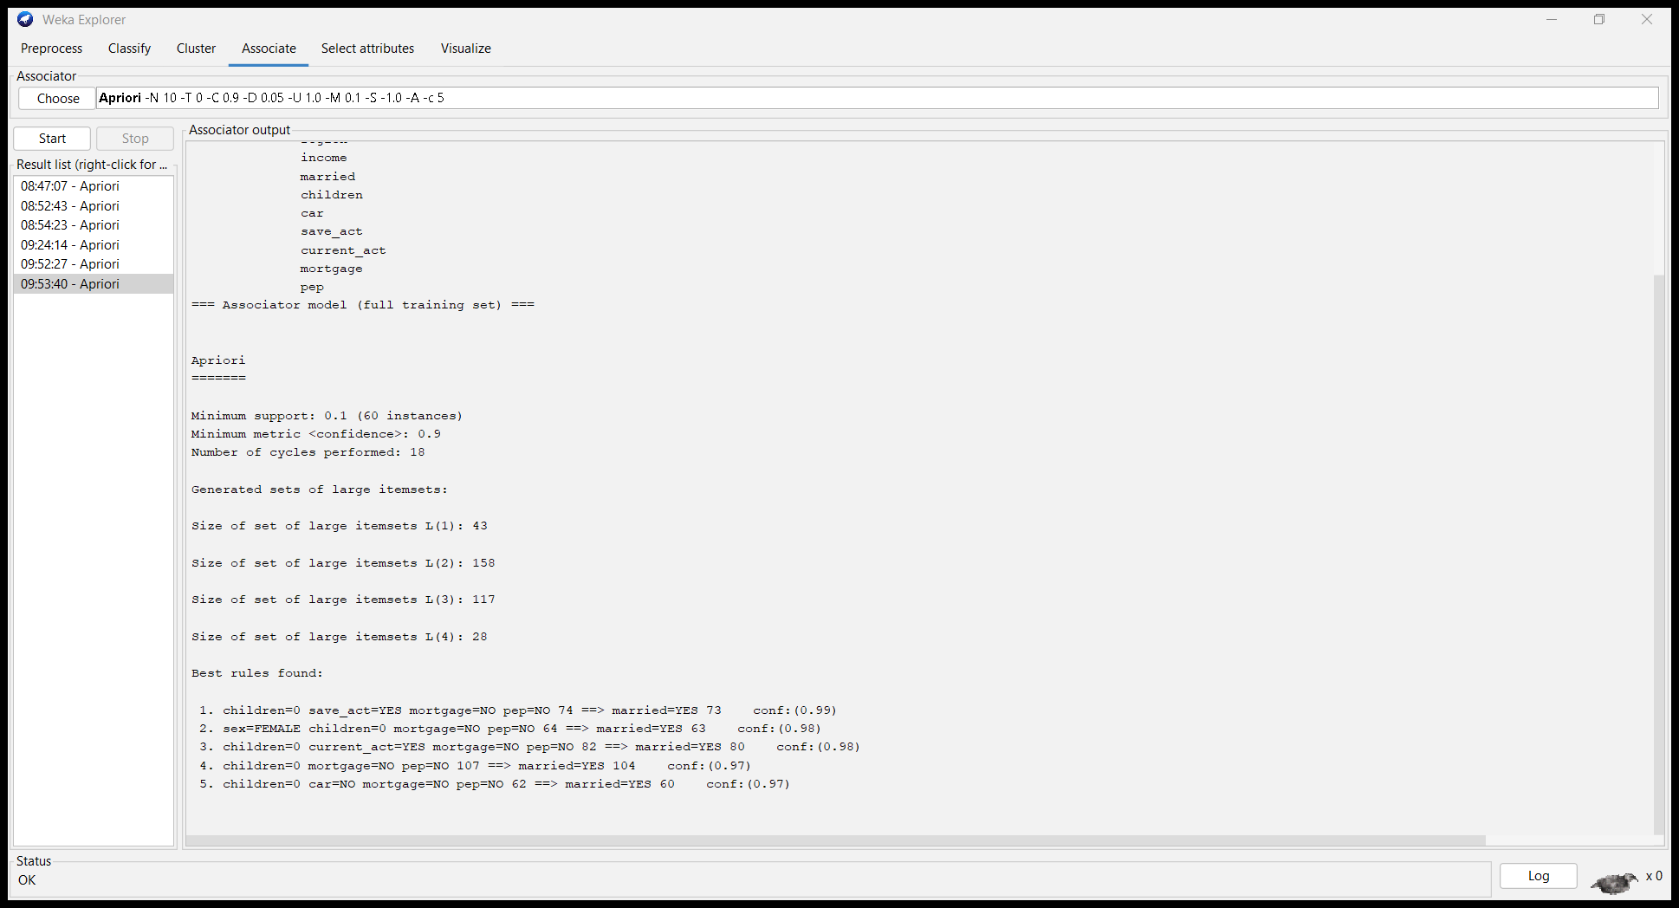

Question 02
The Given Iris Plants Database.csv file contains the attribute of Iris Plants. There’re five attributes about the plant which are, sepal length in cm, sepal width in cm, petal length in cm, petal width in cm, and class.
- Import the data set into Weka
- Open the weka software Click on Explorer then weka Explorer will open within that click on open file Go to the location of the dataset file Double click on that and open it.

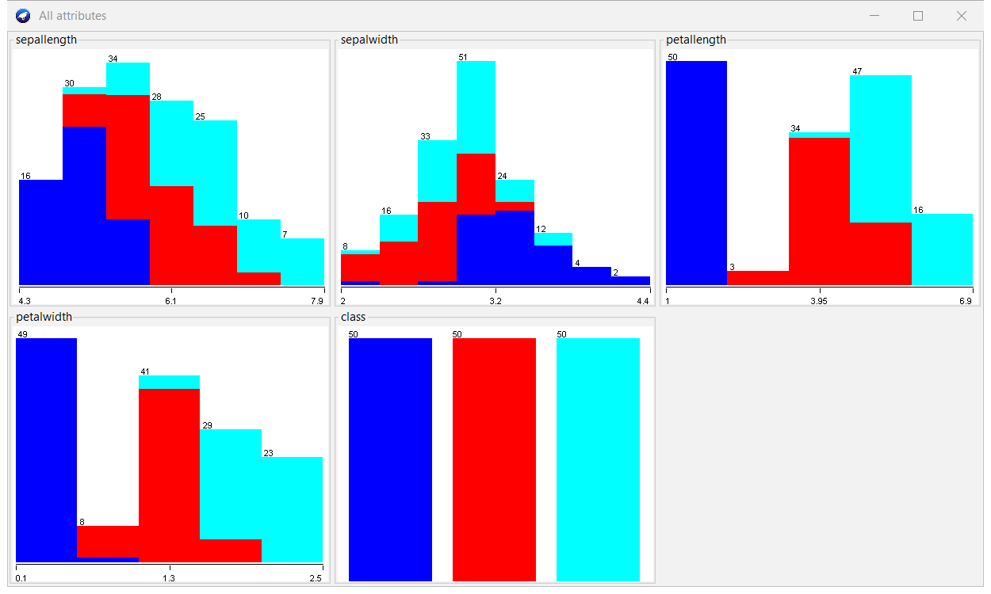
- Visualize All the attribute and interpret the result

- Visualize the scatter plot of the attribute and explain the attribute relations
- In the top menu bar click on the visualized tab
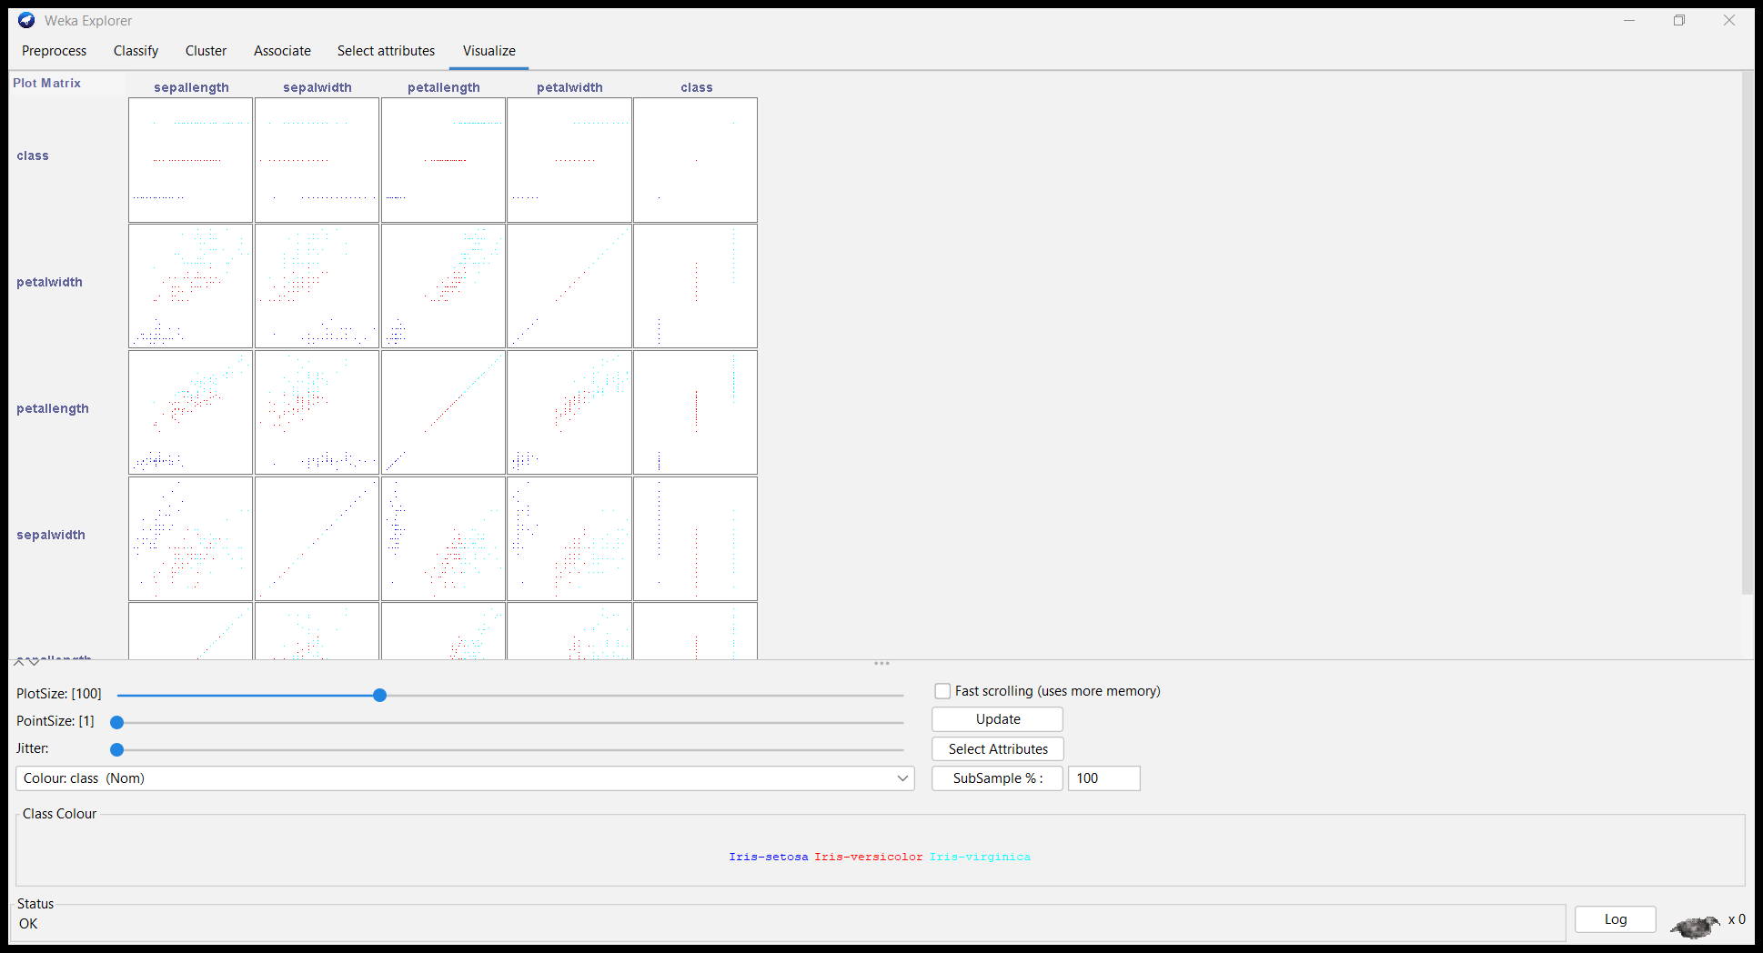

- Sepal Length vs. Sepal Width:
There seems to be no strong linear relationship between sepal length and sepal width.
Data points are scattered without a clear pattern.

- Sepal Length vs. Petal Length:
There appears to be a positive correlation between sepal length and petal length.
As sepal length increases, petal length tends to increase as well.

- Sepal Length vs. Petal Width:
Similar to the previous plot, there’s a positive correlation between sepal length and petal width.
Longer sepals tend to be associated with wider petals.

- Sepal Width vs. Petal Length:
Sepal width and petal length show some variation, but no strong linear relationship is evident.

- Sepal Width vs. Petal Width:
Again, no clear linear relationship between sepal width and petal width.
Data points are scattered across the plot.

- Petal Length vs. Petal Width:
There’s a strong positive correlation between petal length and petal width.
Longer petals tend to be wider as well.

- Preprocess the source file
Under this step we consider two things which is there are any missing values or unwanted attributes there considering given data set there is no that kind of problem so I directly use this data set to discretize process

- discretize all the attribute.
First select the attribute which you want to convert in to nominal Click on “Choose” button under the option called filter Then filter pane will appear Click on filter folder click on unsupervised folder click on attribute folder finally click on discretizes option and click on ok In the filter option Infront of the choose option it will shows the selected filter option click on it Then Genaric object editor pane will appear Enter the relevant attribute number and the number of bin as 3 click on ok click on apply
vi. Change the data label of the converted nominal data type.
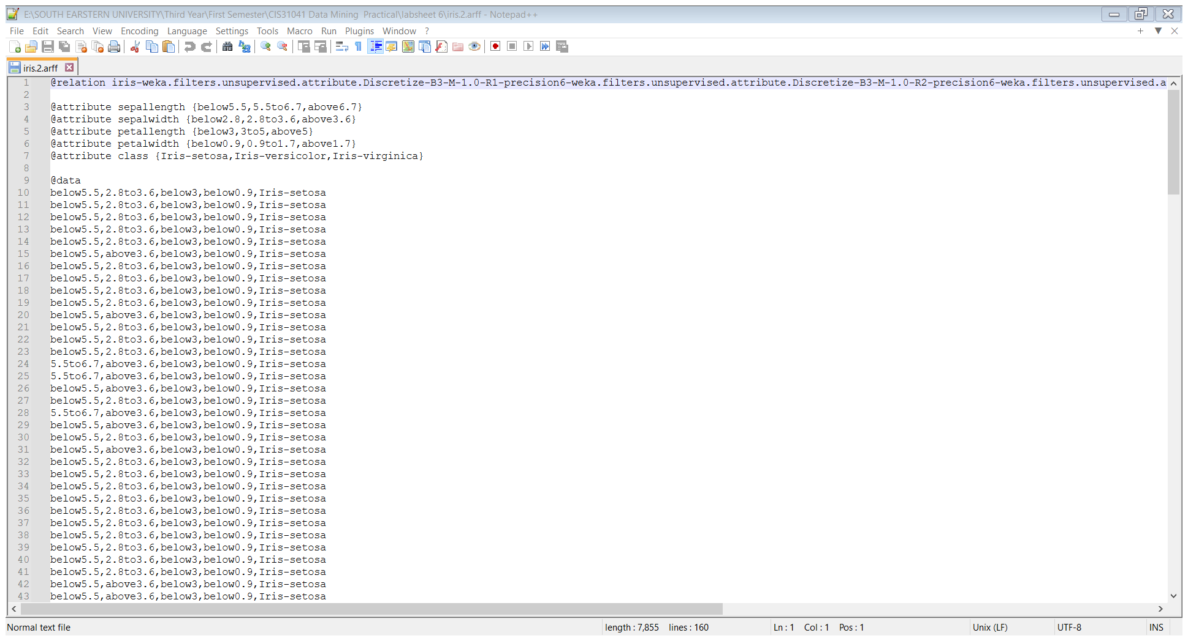

- Apply the association rule mining ‘Apriori’ and set the class attribute as class
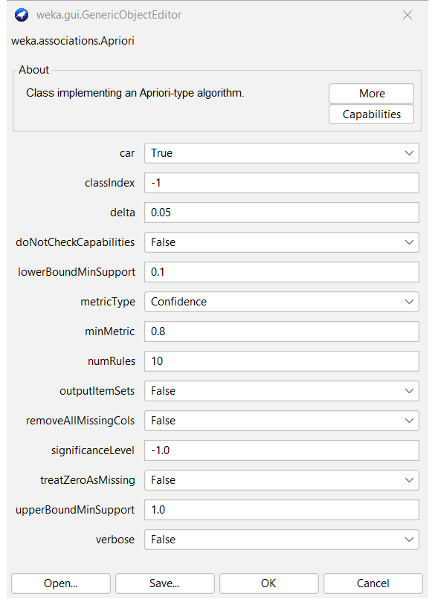

- Explain the association rule mining
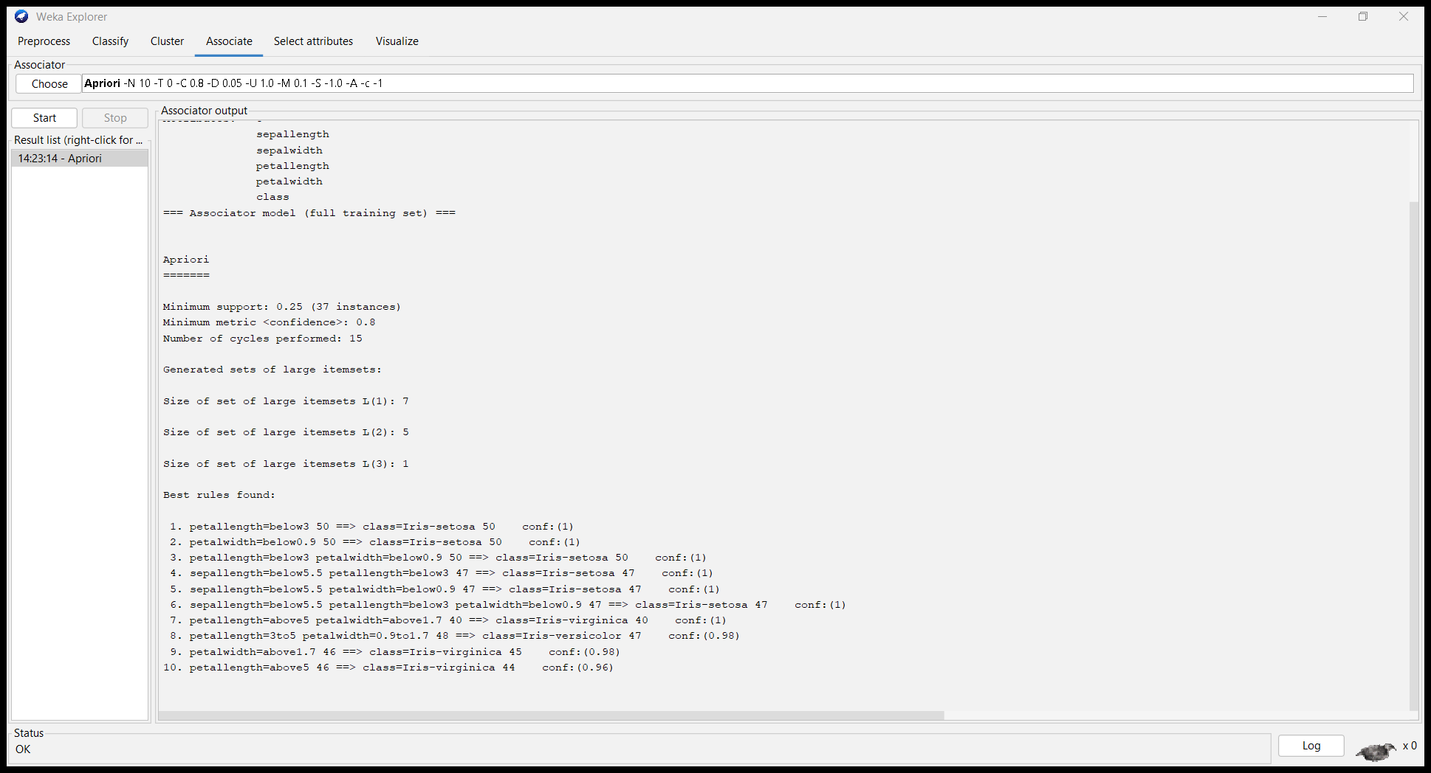
Apriori Parameters:

- Minimum support: 0.25 (37 instances)
- Minimum metric <confidence>: 0.8
- Number of cycles performed: 15

Base on the associate rule. I got 10 rules
1)There is 50 petallength below 3 all those belongs to calss Iris-setosa
2) There is 50 petalwidth below 0.9 all those belongs to class Iris-setosa
3) There is 50 petallength below 3 and petalwidth below 0.9 all those belongs to class Iris-setosa
4) There is 47 sepallength below 5.5 and petallength below 3 all those belongs to class Iris-setosa
5) There is 47 sepallength below 5.5 and petalwidth below 0.9 all those belongs to class Iris-setosa
6)There is 47 sepallength below 5.5,petallength below 3 and petalwidth below0.9 all those belongs to class Iris-setosa
7) There is 40 petallength above and petalwidth above1.7 all those belongs to class Iris-virginica
8) There is 48 petallength 3 to 5 and petalwidth 0.9 but among those 47 belongs to class Iris- virginica
9) There is 46 petalwidth above1.7 among those 45 belongs to class Iris- virginica
10) There is 46 petallength above1.7 among those 44 belongs to class Iris- virginica

Discussion
In today's practical lesson, we learned about the basics of data preprocessing, with a focus on cleaning up data and separating it into different sets. Cleaning the data, which includes things like dealing with missing values, getting rid of duplicates, and handling outliers, makes sure that our dataset is strong and reliable for further research. Data discretization methods, such as equal width binning, equal frequency binning, and clustering-based discretization, on the other hand, can turn continuous data into discrete intervals or categories that make it easier to analyze and model. By mastering these preprocessing methods, we equip ourselves with the necessary tools to extract important insights and build accurate predictive models from our

